U25AI055
Lab-7
- Implement a queue using linked list
#include <iostream>
using namespace std;
struct Node {
int data;
Node *next;
};
void enqueue(Node **front, Node **rear, int element);
int dequeue(Node **front, Node **rear);
bool isEmpty(Node *front, Node *rear);
int frontElement(Node *front);
int main() {
int choice, element;
Node *front, *rear;
front = NULL;
rear = NULL;
do {
cout << "1. Enqueue" << endl;
cout << "2. Dequeue" << endl;
cout << "3. Is empty" << endl;
cout << "4. Front element" << endl;
cout << "Enter choice: ";
cin >> choice;
switch (choice) {
case 1:
cout << "Enter element: ";
cin >> element;
enqueue(&front, &rear, element);
break;
case 2:
cout << "Dequeued " << dequeue(&front, &rear) << endl;
break;
case 3:
if (isEmpty(front, rear)) {
cout << "Empty" << endl;
} else {
cout << "Not empty" << endl;
}
break;
case 4:
cout << "Front element = " << frontElement(front) << endl;
break;
default:
cout << "Invalid choice" << endl;
}
} while (choice >= 1 && choice <= 4);
return 0;
}
void enqueue(Node **front, Node **rear, int element) {
Node *newNode;
newNode = new Node;
if (newNode == NULL) {
cout << "Queue overflow" << endl;
return;
}
newNode->data = element;
newNode->next = NULL;
if (*front == NULL && *rear == NULL) {
*front = newNode;
*rear = newNode;
} else {
(*rear)->next = newNode;
*rear = newNode;
}
}
int dequeue(Node **front, Node **rear) {
if (*front == NULL) {
cout << "Queue underflow" << endl;
return -1;
}
int element = (*front)->data;
Node *temp = *front;
if (*front == *rear) {
*front = NULL;
*rear = NULL;
} else {
*front = (*front)->next;
}
delete temp;
return element;
}
bool isEmpty(Node *front, Node *rear) {
return front == NULL && rear == NULL;
}
int frontElement(Node *front) {
return front->data;
}
Output:
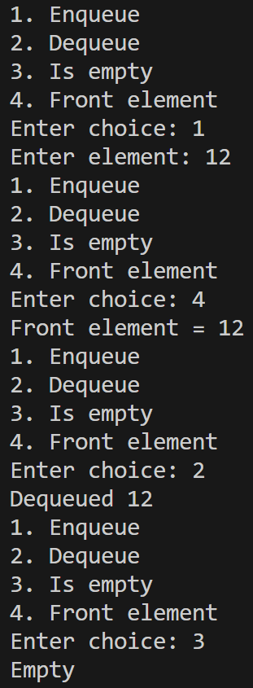
- Implement a priority queue using linked list
#include <iostream>
using namespace std;
struct Node {
int data;
int priority;
Node *next;
};
void push(Node **head, int data, int priority);
int pop(Node **head);
int peek(Node *head);
int main() {
Node *head;
head = NULL;
int choice, data, priority;
do {
cout << "1. Push" << endl;
cout << "2. Pop" << endl;
cout << "3. Peek" << endl;
cout << "Enter choice: ";
cin >> choice;
switch (choice) {
case 1:
cout << "Enter data: ";
cin >> data;
cout << "Enter priority: ";
cin >> priority;
push(&head, data, priority);
break;
case 2:
cout << "Popped " << pop(&head) << endl;
break;
case 3:
cout << "Highest priority data = " << peek(head) << endl;
break;
default:
cout << "Invalid choice" << endl;
}
} while (choice >= 1 && choice <= 3);
return 0;
}
void push(Node **head, int data, int priority) {
Node *newNode = new Node;
if (newNode == NULL) {
cout << "Queue overflow" << endl;
return;
}
newNode->data = data;
newNode->priority = priority;
if (*head == NULL) {
newNode->next = NULL;
*head = newNode;
} else if (priority < (*head)->priority) {
newNode->next = *head;
*head = newNode;
} else {
Node *ptr;
ptr = *head;
while (ptr->next != NULL && ptr->next->priority <= priority) {
ptr = ptr->next;
}
newNode->next = ptr->next;
ptr->next = newNode;
}
}
int pop(Node **head) {
if (*head == NULL) {
cout << "Queue underflow" << endl;
return -1;
}
int element = (*head)->data;
Node *temp;
temp = *head;
*head = (*head)->next;
delete temp;
return element;
}
int peek(Node *head) {
return head->data;
}
Output:
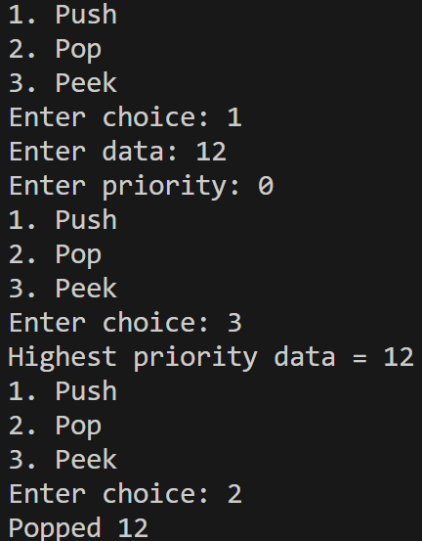
- Implement a circular queue using a circular linked list
#include <iostream>
using namespace std;
struct Node {
int data;
Node *next;
};
void enqueue(Node **front, Node **rear, int element);
int dequeue(Node **front, Node **rear);
int frontElement(Node *front);
int rearElement(Node *rear);
int main() {
Node *front, *rear;
front = NULL;
rear = NULL;
int choice, element;
do {
cout << "1. Enqueue" << endl;
cout << "2. Dequeue" << endl;
cout << "3. Front element" << endl;
cout << "4. Rear element" << endl;
cout << "Enter choice: ";
cin >> choice;
switch (choice) {
case 1:
cout << "Enter element: ";
cin >> element;
enqueue(&front, &rear, element);
break;
case 2:
cout << "Dequeued " << dequeue(&front, &rear) << endl;
break;
case 3:
cout << "Front element = " << frontElement(front) << endl;
break;
case 4:
cout << "Rear element = " << rearElement(rear) << endl;
break;
default:
cout << "Invalid choice" << endl;
}
} while (choice >= 1 && choice <= 4);
return 0;
}
void enqueue(Node **front, Node **rear, int element) {
Node *newNode;
newNode = new Node;
if (newNode == NULL) {
cout << "Queue overflow" << endl;
return;
}
newNode->data = element;
if (*front == NULL && *rear == NULL) {
*front = newNode;
*rear = newNode;
newNode->next = *front;
} else {
(*rear)->next = newNode;
newNode->next = *front;
*rear = newNode;
}
}
int dequeue(Node **front, Node **rear) {
if (*front == NULL) {
cout << "Queue underflow" << endl;
return -1;
}
int element = (*front)->data;
Node *temp;
temp = *front;
if (*front == *rear) {
*front = NULL;
*rear = NULL;
} else {
*front = (*front)->next;
(*rear)->next = *front;
}
delete temp;
return element;
}
int frontElement(Node *front) {
return front->data;
}
int rearElement(Node *rear) {
return rear->data;
}
Output:
